St. Brigid and St. John Catholic Church 2025 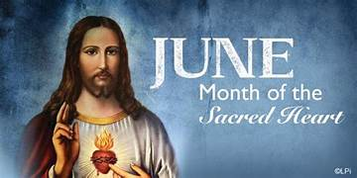
Sunday | Monday | Tuesday | Wednesday | Thursday | Friday | Saturday
1  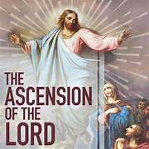 | 2  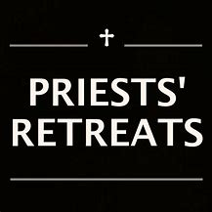  St. Meinrad | Fr. Jeff’s 25th 3  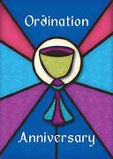 | 4  11:00 CCC, Bring a Dish   | 5  Noon and 6:00 p.m.   | 6 | 7
Donut Sunday 8    25th Anniversary Potluck for Fr. Jeff after 11:00 Mass | 9 | 10  St Brigid Youth  Feeding America  5-7 p.m. | 11 | 12 | 13 | 14
Father’s Day 15  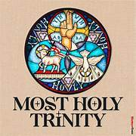 | 16  Backyard Catholic Bible Camp  K-5th grade/St. John  9 a.m. – 5 p.m.  Lunch served | 17 | 18 | 19  Sisters in Christ Road Trip to Cathedral/Lunch   | 20   CCC 9 a.m.– 2 p.m. | 21
22  Corpus Christi Sunday   | 23 | 24 | 25 | 26  . | 27  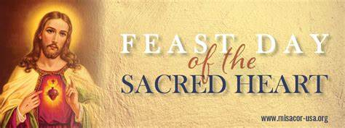 | 28  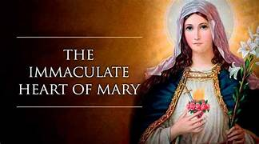
29   | 30  Safe Environment Training @ St. James @ 6:30 p.m.   |  |  |  |  | OVER
*See the bulletin for more information about these events * Follow the St. Brigid Church page on Facebook * Visit the parish website at http://www.stbrigidvg.org
** If you have information you would like to add to the monthly calendar, please submit to the Parish office by the 20th of the prior month. brigidvg@bbtel.com

Bible Study: 10 a.m. On Mondays at St. John

Congratulations to Our Graduating Seniors:

Andres Walker Disselkamp, Andrew Disselkamp, Ella Downs, Ethan Kuhn, Case Padgett, Chase Price, Melia Reddick, Jay Shinault, Larkin Taylor, Gavin Thomas and Benjamin Updegraff from St. John and Tatiana Marchiony from St. Brigid.

