TWENTY-EIGHTH SUNDAY
IN ORDINARY TIME
St. Brigid of Ireland October 12, 2025 St. John the Baptist Catholic Church Catholic Church

E 4

Pastor:
Fr. Jeff Gatlin
Rectory:
270-877-2546
Deacon:
Mike Ryan
Office:
270-272-6789

314 E. Main Street 657 St. John Church Rd.
ANOINTING OF THE SICK:
Notify the parish office when a family member is hospitalized.
BAPTISM: Contact the parish office for information about the required preparation class.

BULLETIN: Submit information in writing by note or email to the parish office no later than 4:00 p.m. on Wednesday for the following weekend. When sending an email, please put “BULLETIN” in the subject line along with the name of the parish it pertains to.

MARRIAGE: Contact Father Jeff or Deacon Mike at least 6 months prior to the wedding date to complete required marriage preparations and to schedule the date.
OCIA (Order of Christian Initiation of Adults): Contact Deacon Mike Ryan (270) 877-0546 or (270) 272-6789
Contact the DEW MEMORIAL LIBRARY:
(St. Brigid Church basement):
Open: Sunday after 9:00 a.m. Mass & 45 minutes before all other Masses.
Vine Grove, KY 40175 Elizabethtown, KY 42701
Clustered Parish Office: Clustered Parish Office:
(270) 877-2461 (270) 877-2461
Email: brigidvg@bbtel.com
Website: www.stbrigidvg.org Dir. of R. Education:
Hillary Henderson (270) 402-7461 stjohndre1@gmail.com
Pastoral Associate
Deacon Mike Ryan: (270) 877-0546
MASS SCHEDULE:
Saturday (Vigil): 6:30 p.m.
Sunday: 11:00 a.m.
Tuesday: 9:00 a.m. Wednesday: 6:30 p.m.

RECONCILIATION:
Saturday before Mass from 5:00-6:00 p.m. or by appt.

PARISH COUNCIL MEMBERS:
President: Greg Thompson
Secretary: Jan Thomas

CHAIRPERSONS:
Administration: David Yates
Formation: Lisa Thomas
Parish Life: Doug Updegraff
Worship: Sarah Mattingly

Youth Minister:
Lori Law: (270) 723-0157
MASS SCHEDULE:
Sunday: 9:00 a.m. & 4:00 p.m.
Monday: 9:00 a.m.
Thursday: 9:00 a.m.
RECONCILIATION:
Sunday before Mass from 2:30 -3:30 or by appt.
ROSARY: After weekday Masses
PARISH COUNCIL MEMBERS:
President: Bill Cochran
Vice-President: Angie Bragg
Secretary: Ken Baker
At-Large Members: Jane Alder
Linda Skeeters
CHAIRPERSONS:
Administration: To be filled
Formation: Tina Yates
Parish Life: Angie Bragg
Worship: Judy Cochran

Sat | Oct 11 | 6:30 p.m. | St. John | For All Parishioners | VIGIL: TWENTY-EIGHTH SUNDAY IN  ORDINARY TIME
Sun | Oct 12 | 9:00 a.m. | St. Brigid | Our Parish Family,  In loving memory  of Joseph Greenwell | TWENTY-EIGHTH SUNDAY IN  ORDINARY TIME
Sun | Oct 12 | 11:00 a.m. | St. John | For All Parishioners | TWENTY-EIGHTH SUNDAY IN  ORDINARY TIME
Sun | Oct 12 | 4:00 p.m. | St. Brigid | In loving memory of Brian Sipes and Allyn Priebe,  In loving memory of Robert Francis Hall | TWENTY-EIGHTH SUNDAY IN  ORDINARY TIME
Mon | Oct 13 | 9:00 a.m. | St. Brigid | In loving memory of the members from Luise Weisshaupt Family | Weekday
Tue | Oct 14 | 9:00 a.m. | St. John | For All Parishioners | Weekday
Wed | Oct 15 | 6:30 p.m. | St. John | For All Parishioners | Saint Teresa of Jesus, Virgin and Doctor of the Church
Thurs | Oct 16 | 9:00 a.m. | St. Brigid | In loving memory of the members from Luise Weisshaupt Family,  In loving memory  of Mac Howard | Weekday
Sat | Oct. 18 | 6:30 p.m. | St. John | In honor of the living and deceased members of Emil and Anna Brangers Family | VIGIL: TWENTY-NINTH SUNDAY IN  ORDINARY TIME
Sun | Oct.19 | 9:00 a.m. | St. Brigid | In loving memory of  Donnie Wooldridge,  In loving memory of the  members from  Robert T. Lancaster Family | TWENTY-NINTH  SUNDAY IN  ORDINARY TIME
Sun | Oct 19 | 11:00 a.m. | St. John | In loving memory  of Joseph Greenwell | TWENTY-NINTH  SUNDAY IN  ORDINARY TIME
Sun | Oct 19 | 4:00 p.m. | St. Brigid | In loving memory  of Leo Padgett,  Our Parish Family | TWENTY-NINTH  SUNDAY IN  ORDINARY TIME
Stewardship Reflections: Twenty-Eighth Sunday in Ordinary Time

“And [Jesus] said to him, ‘ Stand up and go; your faith has made you well.” Luke 17:19

Just like the Samaritan leper, a Christian steward receives God’s gifts gratefully. We must not get so busy that we forget to thank God for all the blessings in our lives.

Our Military List

To add someone to the military list, please call the parish office at (270) 877-2461.
MAJ Jordan Benton, E6 Jose Bonilla, SPC Brenna Brown, 2LT Ryan Cunningham, Sgt. Lance Etsitty, Sgt. Luiz Etsitty,AD3 Seth Filburn, 1Lt Matthew Fischer, 1LT Tyler Hall, 1LT Olivia Jerolaman, 1LT Paul E. Kotarski, A1C Joseph Manco, SFC Peter Novak, LTCMDR Erin Pedersen, James Rogers, Tony Rogers, Jonathon Sifford, Jeffrey Slade, Derek Smith, CSM Vance Snider, Brian Tomassi, A1C Daniel Trombone, SGT Evan Wilson, WO2 Evan Vaughan, SGT Clay M Wilson, SS Shelby Nicole Winchester, TSGT Jeremy Yates, and for all who serve and have served our country.

St. John and St. Brigid Prayer List

To add someone to the prayer list, please call the parish office at (270) 877-2461.
Sam Adams, April Allen, Dennis Arnold, Joe Ash, Shannon Barnes, Denise Barnett, Timothy Birch, Leon Blair, Teresa Blaycock, Charlie Bowers, Everett Brown, Jason Brown, Joseph Bryant. Richard Bryson, Carol Buchanan, Joe Buchanan, Linda Buchanan, Ashley Burnett & Baby Caroline, Jeremy & Margie Buyer, Greg Byerly, Glenn Canaday, Steve Carver, Sue Caswell, Emmett Cecil, Jr. Bobby Chism, Betty Jo Cooper, Rose M. Cooper, James Copley, Denise Corbett, Heidi Correa, Teresa (Terry) Cowley, Jeff Craig, Michael Dalton, Jerry Deom, Judy Deom, Tommy Deom, Roan Dowell, Virginia Drake, Danny Embry, Julie Fagan, Wayne Garcia, Dayle Gilliatt, Danny Greenwell, Carrie Gribben, Joe Pat Hall, Danny Hardesty, N. J. Hardesty, Jimmy Harper, Cheryl Hart, Eileen Heinen, Susan Horton, Frank Inanely, Braddock Inman, Eve Jarboe, Pasita Javier, Paul Jenkins, Betty Lou Jones, Bob Jones, Mark Kennedy, Violet Knoop, Robert Krauser, Mary Colleen Learned, Richard Lee, Jenny Leonhardt, Denzil Lile, Jackie Long, Lori Love, Shelly Martin, Martina Masoni, Ron Masoni, Kay Matheney, Don Mattingly, Paul Michael Mattingly, Kay McGuire, Angela Miles, Tate Miller, Starla Miller, Brixten Muir, Alexandra Munn, David Murray, Aira & Zairah Nixon, Elaine Ray Ogletree, Maggie Olson, Theresa Owens, Bill Padgett, Jim Padgett, Joe Padgett, Johnny Padgett, Bill Pawley, Annie Pierce, Wendy Pike, Adrianna Porter, Jeremy Porter, Mary Ray Portwood, Ernie and Linda Pyzocha, Adrian Ray, Jimmy Ray, Mary Agnes Ray, Rob Redmond, Theresa Riney, Joel Rivera, Betty Robbins, Alaina Rogers, Les and Linda Rogers, Pam Anthony Roy, Margaret Ryan, Pat and Mary Ryan, Russ Salvia, Joe Samu, Margit Sanders, Caroline Seabee, Karen Shaffer, John Sheroan, Erica Shook, Brittany Sines, Greg Skeeters, Karen Smith, Magdalena “Maggie” Smith, Sheila Smith, Greg Stevens, Nolan Stith, Joe Thomas, Robert L. Thomas, Norbert Thompson, Debi Turner, Mary Ann Vance, Stacey Vance, Stacy Vessels, Kathy Watkins, Mary Via, Elfriede Wheeler, Paul A. Whelan, Jan Wilke, Jennifer Williams, Lucas Williams, Gail Wilson, Marie Wirth, Connor Wright, Joe Herman Yates, Tony Yates and all the sick, both mentally and physically.

For Both Parishes

​
PICKLEBALL – Saint Brigid gym is open for pickleball on Mondays and Thursdays at 9:30 a.m. Come, enjoy the physical activity, and have fun at the same time.
GYM WALKING – St. Brigid gym is open M-W-F mornings from 8:00 a.m.-10:00 a.m. for anyone who would like to come walk.
SPECIAL DISCIPLES OF JESUS MASS All are welcome! We hope your family will join us for the Special Disciples of Jesus Mass. We invite all Special Needs family and friends to St. Margaret Mary on Sunday, October 26th at 3PM. We know Mass can be a struggle for many families, so we hope to have a beautiful, unique celebration together where all feel welcome. Just come as you are! Your family will be welcomed with open arms and will hopefully meet other families in similar situations. The Mass will be shorter and geared towards our children. We hope to foster a Catholic community here with fellowship following Mass, so stick around to meet other families and kids. A light reception will follow in the Hospitality Room. For questions, more information or if you would like to help in this ministry, please contact Tara Mattingly at 502-690-2851 or tmattingly@stmm.org

The Archdiocese of Louisville is sponsoring the annual ACCOMMODATE 2025: A College and Career Night for Students Seeking Support Services and Post-Secondary Career Opportunities. This event will take place at Sacred Heart Academy Gym (3115 Lexington Road, Louisville) on Thursday, November 6, 2025, from 6 p.m. to 7:30 p.m.
Representatives from colleges, universities, and alternative post-secondary programs will offer information and resources for parents and students who are exploring: How colleges and universities are addressing the needs of students with learning differences. Alternative choices for a 4-year college track. Availability of community resources to support college students. Post-secondary career opportunities .No advance registration is required, and the event is free and open to the public. Please contact Vivian Cornell at vcornell@archlou.org or 502/585-3291 for more information.
SAVE THE DATE – Come join us for a night of fun on October 23, 2025, 6:00 p.m. @ St. Brigid Café. Spaghetti dinner, salad, bread, drinks and dessert provided.

St. John The Baptist Catholic Church

Monthly Budget Amount Needed: $13,854.17
Monthly Collection for September: $15,514.78
Monthly Collection for October: $ 3,960.36
Saint Vincent de Paul for September: $ 78.00

WELCOME PACKETS – If you would like to become a member, or learn more about St. John Parish, please take a Welcome Packet in the church lobby. You may return the stewardship form to Father Jeff or place it in the collection basket.

WOMEN’S BIBLE STUDY - 9:30-10:45 : St. John Rectory Every Sunday during RE
Our Women’s Bible Study is a welcoming space to dive into Scripture, share real-life struggles and joys from the week, and grow together in faith. It’s a meaningful time to connect with other women and moms who are seeking encouragement, friendship, and a deeper relationship with God.

CHILI SUPPER – October 25, 2025, stop by before or after Mass and support Youth Group by purchasing a bowl of chili! The funds raised will help our youth with Angel Tree shopping. We’ll also have chili to go if you’d rather not cook. Enjoy a delicious meal while supporting a great cause!
STEWARDSHIP ROUND TABLE DISCUSSION- October 29 after 6:30 Mass. Looking for ideas and ways we can make our January stewardship drive successful. All are welcome to come and share their thoughts. Point of contact- Clarissa Yates 270-766-7821

ROAD TRIP- Our next road trip will be to St Helen's in Glasgow, Monday, Oct 27. We will leave St. John parking lot at 10:00 a.m. All are welcome. This is another pilgrimage site for this Jubilee year.

St. John Liturgical Ministers

VIGIL: TWENTY-EIGHTH SUNDAY  IN ORDINARY TIME | Saturday, October 11, 2025, 6:30 p.m.
Eucharistic Ministers | Joanna Sherrard, Becky Thomas,  Lori Shinault
Lector | Lori Shinault
Gift Bearers | Lori and Jay Shinault
Greeter | Rhonda Newton
Servers | Volunteers
TWENTY-EIGHTH SUNDAY  IN ORDINARY TIME | Sunday, October 12, 2025, 11:00 a.m.
Eucharistic Ministers | Martha Thomas, Jennifer Updegraff,  Abby Wright
Lector | Cindy McLain
Gift Bearers | Linda and Nick Thomas
Greeter | Clarissa Yates
Servers | Ben Updegraff, Kate Disselkamp
VIGIL: TWENTY-NINTH SUNDAY  IN ORDINARY TIME | Saturday, October 18, 2025, 6:30 p.m.
Eucharistic Ministers | Rhonda Newton, Mary Ellen Williams,  Amy Thomas
Lector | Amy Thomas
Gift Bearers | John Thomas Family
Greeter | Shannon Burba
Servers | Volunteers
TWENTY-NINTH SUNDAY  IN ORDINARY TIME | Sunday, October 19, 2025, 11:00 a.m.
Eucharistic Ministers | Libby Brangers, Dennis Thomas,  Scott Mattingly
Lector | Scott Mattingly
Gift Bearers | Gary and Libby Brangers
Greeters | Libby Brangers
Servers | Riley and Olivia Leasor

Ushers for October 2025: Saturday 6:30 p.m. Mass – John Thomas, Zach Thomas
Sunday 11:00 a.m. Mass – Mitchell Thomas, David Yates

St. Brigid Catholic Church

Monthly Budget Amount Needed: $29,758.33
Monthly Collection for September: $ 33,579.84
Monthly Collection for October $ 9,552.00
St. Vincent de Paul for September: $ 677.00

WELCOME PACKETS – If you are interested in joining our parish, please pick up a Welcome Packet at the church doors. Complete the registration form and either drop it in the collection basket or mail it to the office. If you just need to update your registration, there are also forms available.

REMINDER – please sign up your child for religious education classes. We are looking forward to a fabulous fun-filled year.

TRUNK OR TREAT DONATION BOX - The trunk or treat donation box is out and ready to be filled. Please help us with delicious candy donations for this worthy community ministry. God bless you all. Peace Mike

TRUNK OR TREAT – Trunk or Treat will be Friday, October 31, 2025, in the CCC Building. It will start at 5:30 p.m. and end at 8:00 p.m. Please come out and support this worthwhile community ministry. There will be free hot dogs and water. Pork burgers will be available at $3.00 each or 2 for $5.00.

GIVING TREE – With the holidays approaching quickly, St. Brigid Parish will begin the annual tradition of the Giving Tree. This activity invites parishioners to take an ORNAMENT with a gift suggestion attached from the Giving Tree. It is important that if you take an ORNAMENT that you return it with the gift and place it under the tree. THE ORNAMENT WILL NEED TO BE PLACED IN THE PLASTIC BOX. (That allows us to use the ornament year after year.) When the tree is bare, we will see that we have given our all and we will feel in our hearts that someone had a wonderful Christmas. The gift cards that are returned will be removed after each Mass for safe keeping. The gift cards will be given to Hardin County Schools Family Resource and Youth Service Centers in our Parish Communities. They will be used for those who have fallen through the cracks or experienced some unexpected loss this holiday season. The FRYSC coordinators express each year how these cards have really helped those with the most needs. There are also gifts for residents of Signature Rehabilitation Center in Radcliff. Special thanks to Deacon Mike for taking care of setting up and decorating the Giving Tree and assuring that the gift cards are delivered to the Board of Education. Thanks to Pat Billings for taking the gift items to Signature Health. This Giving Tree was started many years ago by my friend Tom Billings and gently handed it off to me. I continue it in Tom’s honor and memory, with the help of all in our parish.

St. Brigid Liturgical Ministers

TWENTY-EIGHTH SUNDAY IN ORDINARY TIME _________________________________________  Eucharistic Ministers | Sunday, October 12, 2025, 9:00 a.m.
Bill Cochran, Rosie Cochran,
Alison Dupont, Toni Lynn Irwin
Lector | Kathy Dowdell
Gift Bearers | Mark Cochran
TWENTY-EIGHTH SUNDAY  IN ORDINARY TIME | Sunday, October 12, 2025, 4:00 p.m.
Eucharistic Ministers | Mike Curry, Ina Curry,  Emma Riney, Tim Cooper
Lector | Kathleen Bramlett
Gift Bearers | Rondale Ates
TWENTY-NINTH SUNDAY  IN ORDINARY TIME | Sunday, October 12, 2025, 9:00 a.m.
Eucharistic Ministers | Alison Dupont, Helen Hick,  Sue Weisshaupt, Angie Bragg
Lector | Kathy White
Gift Bearers | Jim Klimesh
TWENTY-NINTH SUNDAY  IN ORDINARY TIME | Sunday, October 12, 2025, 4:00 p.m.
Eucharistic Ministers | Mike Hall, Stephanie Hall.  Ashley Osterhage, Ken Spangenberger
Lector | Rebecca Ates
Gift Bearers | Michael Bramlett

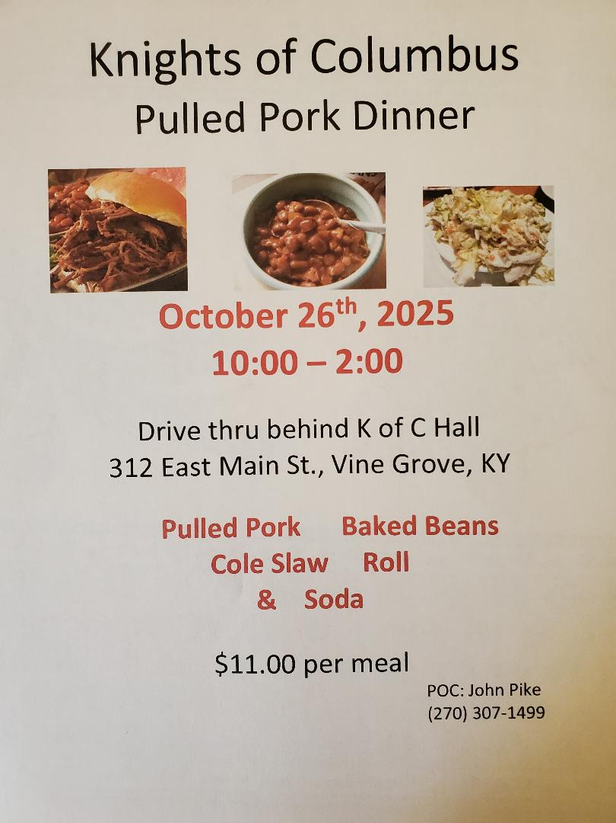
Formation:

Small Christian Community with Christa Pelc will begin Sunday, October 12 through November 9th, 2025, following the 9:00 a.m. Mass in the classroom under the Church. This will be a continuation of The Program of Mary.
Small Christian Community with Jane Alder will begin Tuesday, October 14 through November 11th, 2025, at 9:00 a.m. in the St. Brigid Room in the CCC. This will also be a continuation of The Program of Mary.

SAVE THE DATE! Advent Tea will be held on December 7 from 2-4 p.m. in the CCC. We welcome all men, women, teens to this event! More information to come.

