St. Brigid and St. John Catholic Church 2025 
Sunday | Monday | Tuesday | Wednesday | Thursday | Friday | Saturday
 | 1  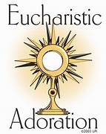  St. Brigid 9:30-11am  Finance Mtg 4:00/St. Brigid | Fr. Jeff Presenting 2  Video of Pope Leo’s  Life – “Leo from Chicago”  10:00 a.m. @ St. John  6:30 p.m. @ St. Brigid Café | Young at Heart 3  11:00 am/ CCC  St. John 5-6:00 pm | 4    St. John Noon and 6:30 p.m. | 5 | 6
7  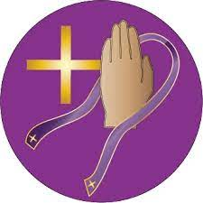  First Reconciliation/St. Brigid  2:00 p.m.  Advent Tea, 2-4  St. Brigid CCC | 8  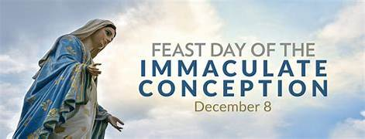  Mass: 9:00 a.m. St. Brigid  6:30 p.m. St. John  Eucharist Adoration after Mass until 11 am./St. Brigid | 9  Sisters in Christ Road Trip/Shrine of St. Martin of Tours/Louisville    5-7 p.m. | 10  St. John 5-6:00 pm | 11 | 12 | 13
Donuts After 9:00 Mass 14  St. John RE Christmas Party Last class until 1/4/26  Testify 4:00 pm @ St. John | 15  St. Brigid 9:30 – 11am | 16 | 17  St. John 5-6:00 pm | 18 | 19  Blood Drive CCC 9-2  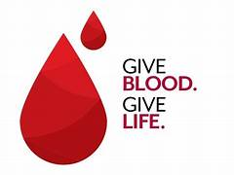 | 20
21  St. Brigid RE last class until 1/4/2026 | 22  St. Brigid 9:30-11am | 23 | 24  Christmas Eve Mass times:  4:00 pm @ St.Brigid  7:00 pm & 10:00 pm @ St. John | Mass: 25  10:00 am St. Brigid  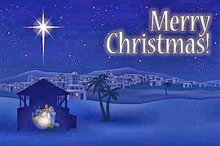 | 26 | 27
28  No RE St. John or St. Brigid  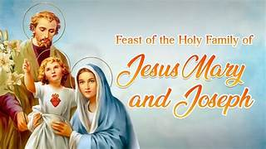 | 29  **Church office closed  Until January 5 | 30 | 31  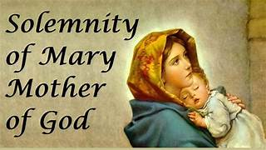  Vigil Mass/St. John @ 5:30 | January 1st, Holy Day Mass at St. Brigid at 10:00 a.m.
Feast of the Immaculate Conception: Holy Day of Obligation: December 8
Mass times: 9:00 a.m. @ St. Brigid, 6:30 p.m. @ St. John the Baptist

Christmas Mass Schedule:
St. Brigid – Christmas Eve 4:00 p.m. Christmas Day 10:00 a.m.
St. John – Christmas Eve 7:00 p.m. and 10:00 p.m.

Solemnity of Mary Holy Day Mass Schedule:
St. John - Wednesday, December 31st @ 5:30 p.m. Vigil Mass
St. Brigid - Thursday, January 1st @ 10:00 a.m.

Father Jeff will be visiting family from December 29 - January 9th
** Per Archdiocese, Parish office to be closed 12/24/2025 – 1/5/2026 – answering machine will be checked regularly and staff will be in and out.

