St. Brigid and St. John the Baptist Catholic Church 2026
Sunday | Monday | Tuesday | Wednesday | Thursday | Friday | Saturday
 |  |  |  | 1  Solemnity of Mary  Mass 10:00 a.m. St. Brigid  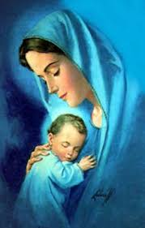 | 2 | 3
4 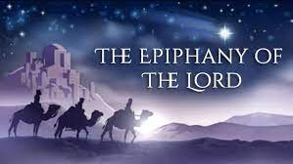  RE Starts back both Parishes | 5  Parish Office Re-opens  St. John Bible Study 10-12-Studying the Book of James | 6 | 7  Young At Heart  11:00 St. Brigid Room  Potluck | 8  Sisters in Christ Noon Potluck and 6 pm at JR Neighbors | 9  Father Jeff returns | 10
11  Donuts/Café After Mass  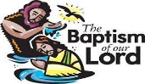 | 12 | 13 | 14 | 15 | 16 | 17
18 | 19  St. John Youth-Activate-Louisville 10-2  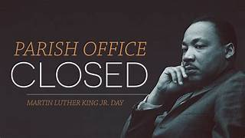 | 20 | 21 | 22 | 23 | 24
25 | 26 | 27 | 28 | 29 | 30 | 31  OVER
*See the bulletin for more information about these events * Follow the St. Brigid and St. John pages on Facebook * Visit the parish website at http://www.stbrigidvg.org ** If you have information you would like to add to the monthly calendar, please submit to the Parish office by the 20th of the prior month. brigidvg@bbtel.com
Solemnity of Mary – January 1, 2026
Among the Twelve Days of Christmas, the Solemnity of Mary is observed on January 1 every year by the Latin Rite of the Catholic Church. It is the eighth day of Christmastide and is a feast to celebrate Mary's motherhood. It is also known as the Solemnity of the Blessed Virgin Mary, the Mother of God.
Way back in 431, there was a bitter controversy among theologians over the role of Mary in the Catholic Church. They debated the question: Who is Mary in God’s plan? In the end, the bishops declared that Mary is really the mother of Jesus and Jesus is really God. So it must be said that Mary is the Mother of God. The oldest Christian greeting of Mary was proclaimed when Mary’s relative Elizabeth called her “Mother of my Lord.” When Elizabeth welcomed Mary, she recognized both the great privilege God had given Mary and Mary’s great faith in accepting it.
For centuries, Mary has been praised because she believed. She is Mother of God because of her faith in God. The Solemnity of Mary, Mother of God, celebrates Mary’s faith and trust in God alone. The Church wants us to imitate her faith. As published by Loyola Press
The Epiphany - January 4, 2026
This feast marking the end of Christmas is called “Epiphany.” In the Latin Rite of the Catholic Church, Epiphany celebrates the revelation that Jesus was the Son of God. It focuses primarily on this revelation to the Three Wise Men, but also in his baptism in the Jordan and at the wedding at Cana. Epiphany is celebrated with special pastries in many countries, and children often receive small gifts in their shoes in honour of the Magi's gifts to the infant Jesus. The holiday also has a number of traditions involving water as a reflection of Jesus' baptism, including the blessing of houses with holy water.
Published by Shrine of St. Jude.org
The Baptism of the Lord - January 11, 2026 – While not a holy day, this day signifies the end of the Christmas Season on the Liturgical Calendar.
The Baptism of the Lord is notable because it marks the beginning of Jesus’ ministry and confirms his identity as the Son of God. This event is documented in all the gospels except John. His emergence from a life of seeming obscurity into a life of growing popularity on account of His preaching, miracles, healings and proclamation of mercy and forgiveness. Christ’s baptism remarkably shows all three Persons of the Trinity at the same time: the Son being baptized, the Holy Spirit descending, and the Father speaking from the heavens. In this event, the Father and the Holy Spirit confirm the deity of Christ, and Jesus submits to his Father’s will.

DON’T FORGET ROOM AT THE INN IS ALWAYS IN NEED OF VOLUNTEERS!!! CONTACT ELAINE OR SAUNDRA AND SIGN UP!!

